

Faculty of Computers and Artificial Intelligence

Computer Science Department

2021/2022

**CS 396 Selected Topics in CS-2**

**Research Project**

Report Submitted for Fulfillment of the Requirements and ILO’s for Selected Topics in CS-2 course for Fall 2021

Team ID No. 8454

|  |  |  |  |
| --- | --- | --- | --- |
|  | ID | Name | Grade |
|  | 20180437 | كيرلس جورج نسيم رياض |  |
|  | 20180441 | كيرلس ميشيل سعيد |  |
|  | 20180615 | ملاك عماد عبد الملاك |  |
|  | 20180284 | سيف هشام سالم |  |
|  | 20180413 | فادي فايق ثابت |  |
|  | 20180285 | شادي ذكري رشدي |  |
|  |  |  |  |

Delivered to:

**Dr. Wessam El-Behaidy**

**Eng. Salma Doma**

**Eng. Ahmed Nady**

* **Paper Details**
* Paper Name: Multi-Class Weather Classification Using ResNet-18
* CNN for Autonomous IoT and CPS Applications.
* Authors : Qasem Abu Al-Haija , 2Mahmoud A. Smadi , 1Saleh Zein-Sabatto

Received: 2020 International Conference on Computational Science and Computational Intelligence (CSCI)

* **Project Description**

Dataset contain images of cloudy, rain, shine and sunrise

Making preprocessing of the images:

1. **Image Resize**: This operation is responsible to unify the image dimensions and depth for all images in the dataset to accommodate the input size for the ResNet-18. Thus, we have developed a MATLAB function to convert all images into 3D matrices (RGB images) with image dimension of 256 x 256 x 3

with JPG image extension

1. **Label Encoding**: This operation is responsible to encode the categorical labels into numerical labels to be understood by machine learning models. Therefore, we have used the integer encoding technique to end up with four labels as follows: cloudy:1, rainy:2, shiny:3, foggy 4and sunrise:5
2. **Dataset Shuffling**: This operation is responsible to randomly rearrange the dataset images to enhance the

classification by generating unbiased distribution of the dataset which avoid model biasing toward specific class(s).

1. **Data Augmentation**: This operation is responsible to effectively increase the amount of training data by applying randomized augmentation operations on the dataset. Augmentation process configures a set of pre-processing options such as resizing, cropping, rotation, reflection, invariant distortions, and others
2. **Data Distribution**: This operation is responsible to randomly split the dataset into training set and testing (validation) set. To ensure high level of unpredictability, random-cross validation process to examine the accuracy of the model at different distributions of dataset.

Training dataset :

1274 images belonging to 5 classes

Validation dataset : 226 images

Test dataset : 30 images

Training dataset before split :

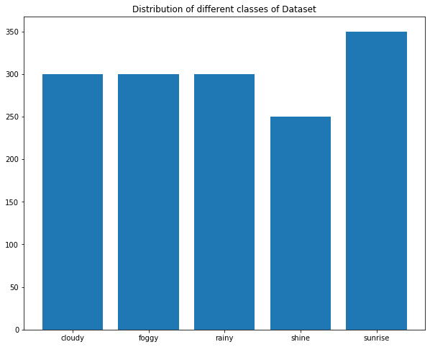

# 

Validation dataset after split :

Training dataset after split :

# 

# 

* **Implementation details**

|  |  |
| --- | --- |
| Model name | accuarcy |
| CNN implementation Model | 0.5667 % |
| CNN implementation Model with Augmentation | 0.633 % |
| Res-Net50 with CNN Layers with Augmentation  Structure | 0.589 % |
| VGG16 with Data augmentation + Dense Layers + Dropout + BatchNormalization | 0.93 % |
| VGG19 with Data augmentation + Dense Layers + Dropout + BatchNormalization | 0.84 % |
| Inceptionv3 with Data augmentation + Dense Layers + Dropout + BatchNormalization | 0.30 % |
| Efficientnet with Data augmentation + Dense Layers + Dropout + BatchNormalization | 0.80 % |
| Res-Net152 with Data augmentation + Dense Layers + Dropout + BatchNormalization | 0.87 % |
| ResNet101 + Data augmentation + Dense Layers + Dropout + BatchNormalization | 0.97 % |

Model selected is : ResNet101 + Data augmentation + Dense Layers + Dropout + BatchNormalization

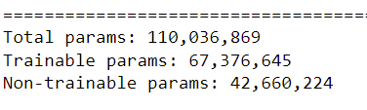

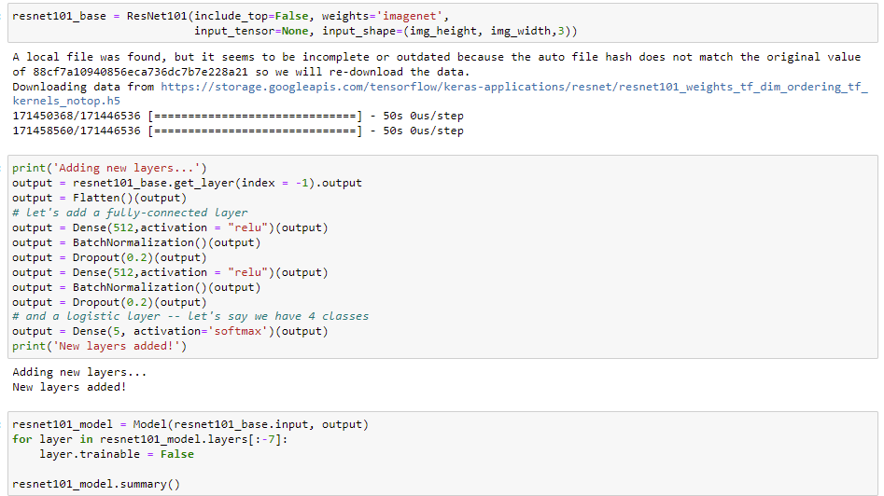

**Testing results**

**When we keep Lr default and use Adam Optimizer: (Training and Validation loss curve)**

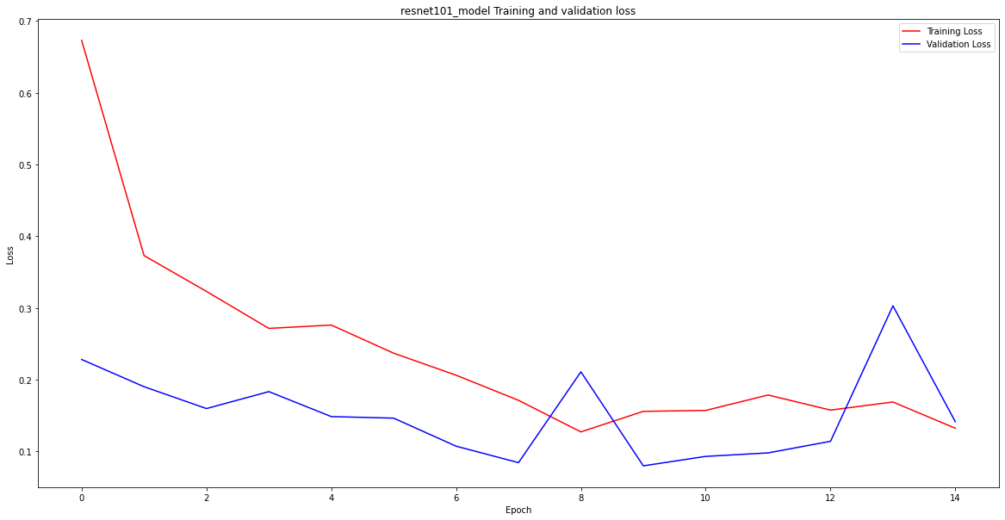

**(Training and Validation accuracy curve)**

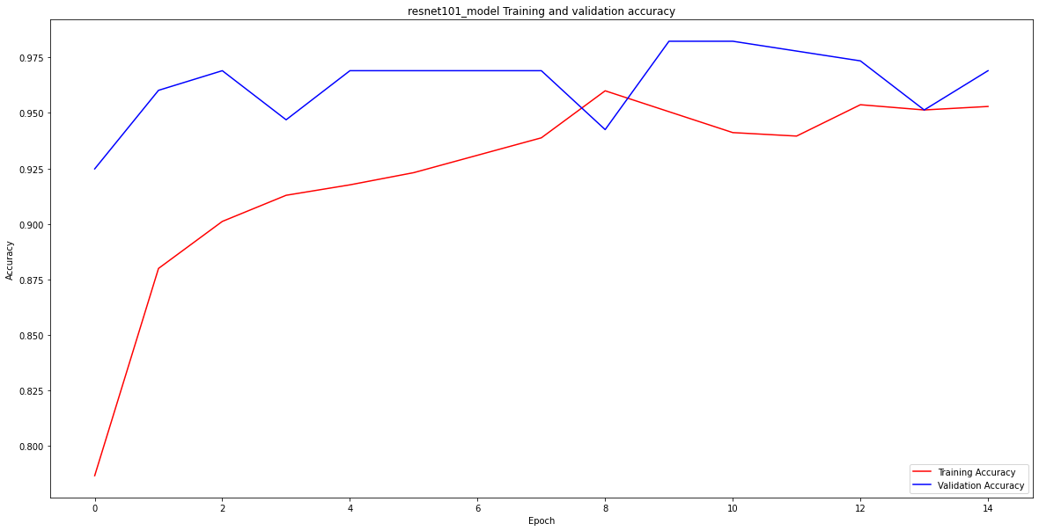

**Confusion matrix:**

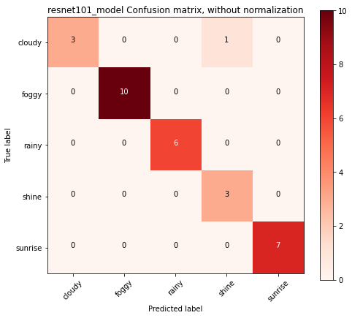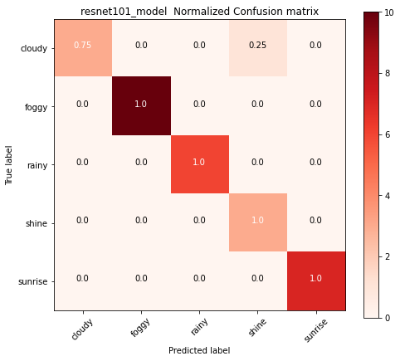

Classification Report:

